## **Create a storage account**

A storage account is an Azure Resource Manager resource. Resource Manager is the deployment and management service for Azure. For more information, see [Azure Resource Manager overview](https://learn.microsoft.com/en-us/azure/azure-resource-manager/management/overview).

Every Resource Manager resource, including an Azure storage account, must belong to an Azure resource group. A resource group is a logical container for grouping your Azure services. When you create a storage account, you have the option to either create a new resource group, or use an existing resource group. This how-to shows how to create a new resource group.

**To create an Azure Blob storage account with the Azure portal, follow these steps:**

1. From the left portal menu, select Storage accounts to display a list of your storage accounts. If the portal menu isn't visible, click the menu button to toggle it on.
2. On the Storage accounts page, select Create.
3. Select the subscription for the new storage account.
4. Create a new resource group for this storage account, or select an existing one.

**Instance details**

1. Choose a unique name for your storage account. Storage account names must be between 3 and 24 characters in length and may contain numbers and lowercase letters only.
2. Select the appropriate region for your storage account.
3. Not all regions are supported for all types of storage accounts or redundancy configurations.
4. Select Standard performance for general-purpose v2 storage accounts (default). This type of account is recommended by Microsoft for most scenarios.
5. Select your desired redundancy configuration. Not all redundancy options are available for all types of storage accounts in all regions.
6. Remaining default options are enough to create azure blob storage.

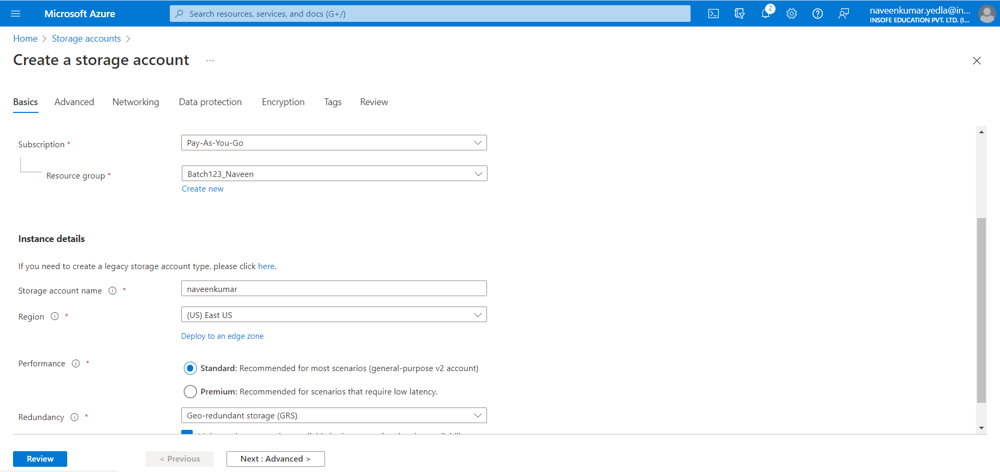

1. When you navigate to the Review + create tab, Azure runs validation on the storage account settings that you have chosen. If validation passes, you can proceed to create the storage account.
2. If validation fails, then the portal indicates which settings need to be modified.
3. The following image shows the Review tab data prior to the creation of a new storage account.

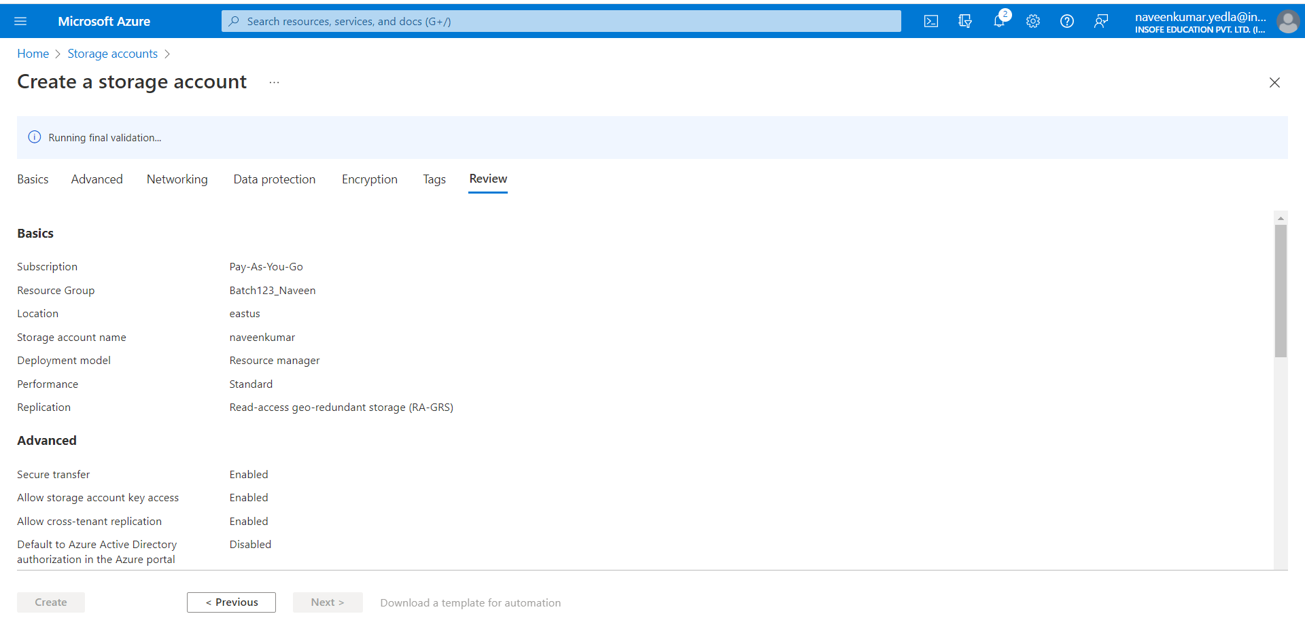

1. Go to the resource of the storage account which you have created

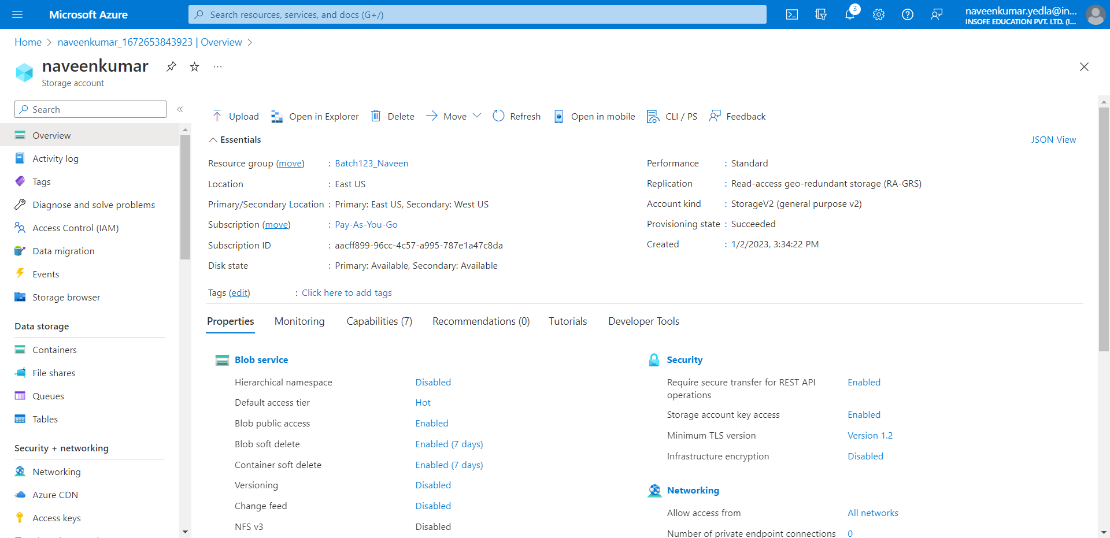

1. Select containers block and click on create container. Select the storage account container.

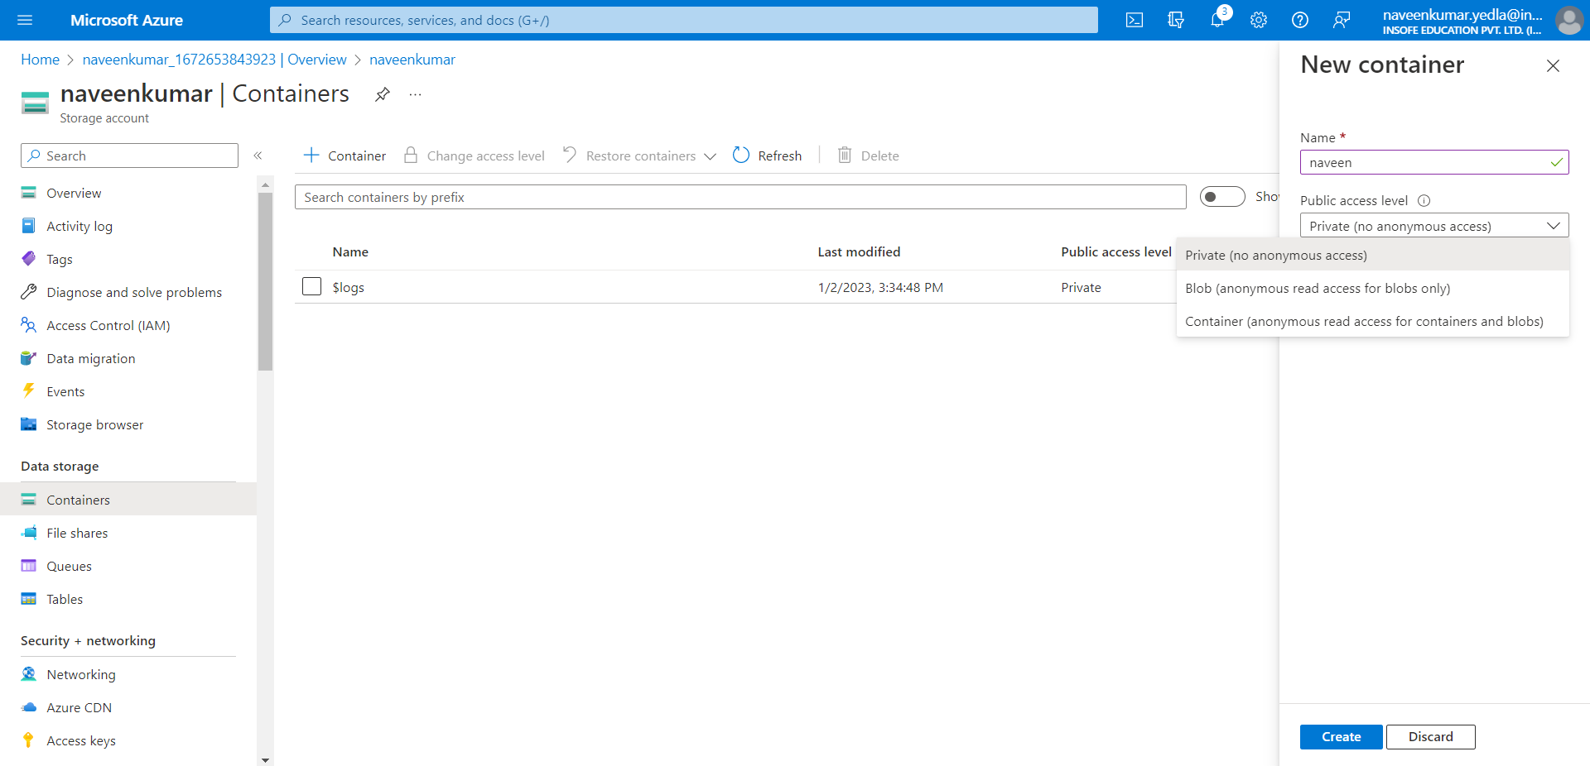

1. Open the container which you have created.
2. Click on upload.

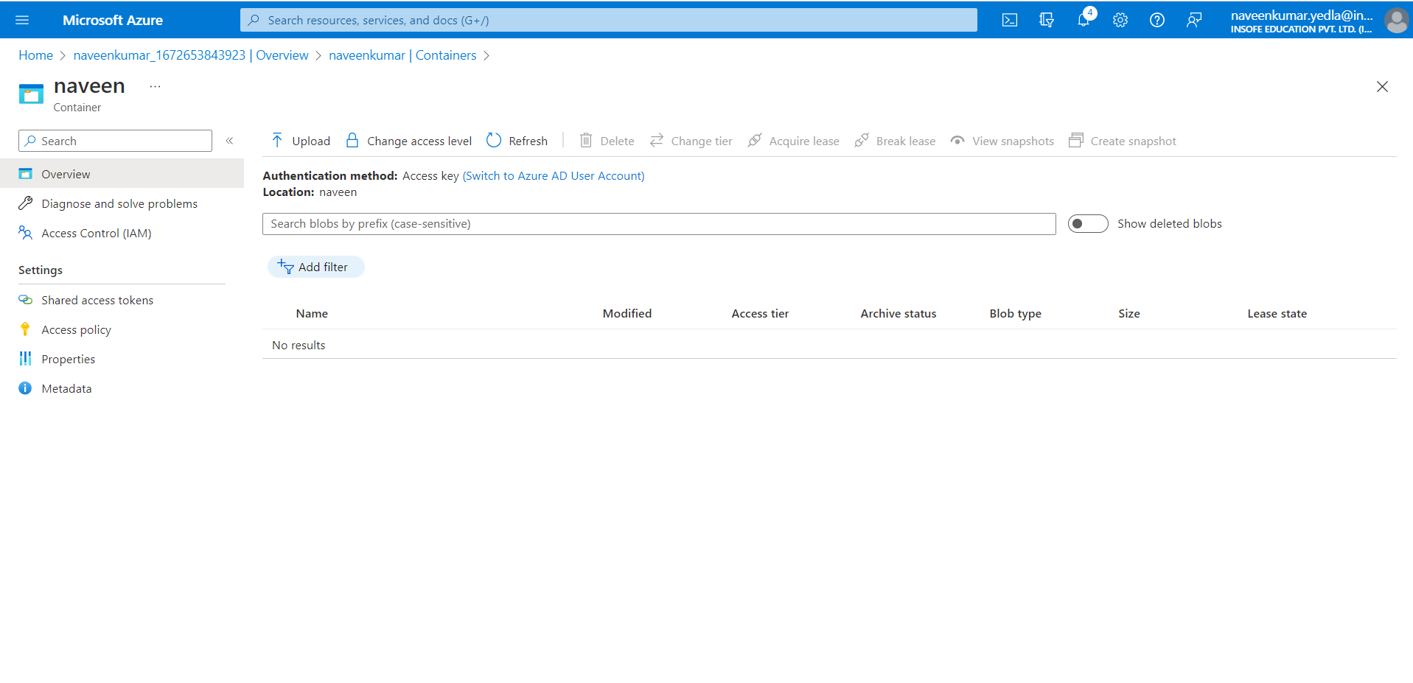

1. Click on select file and upload any image or text file.
2. Click on upload.

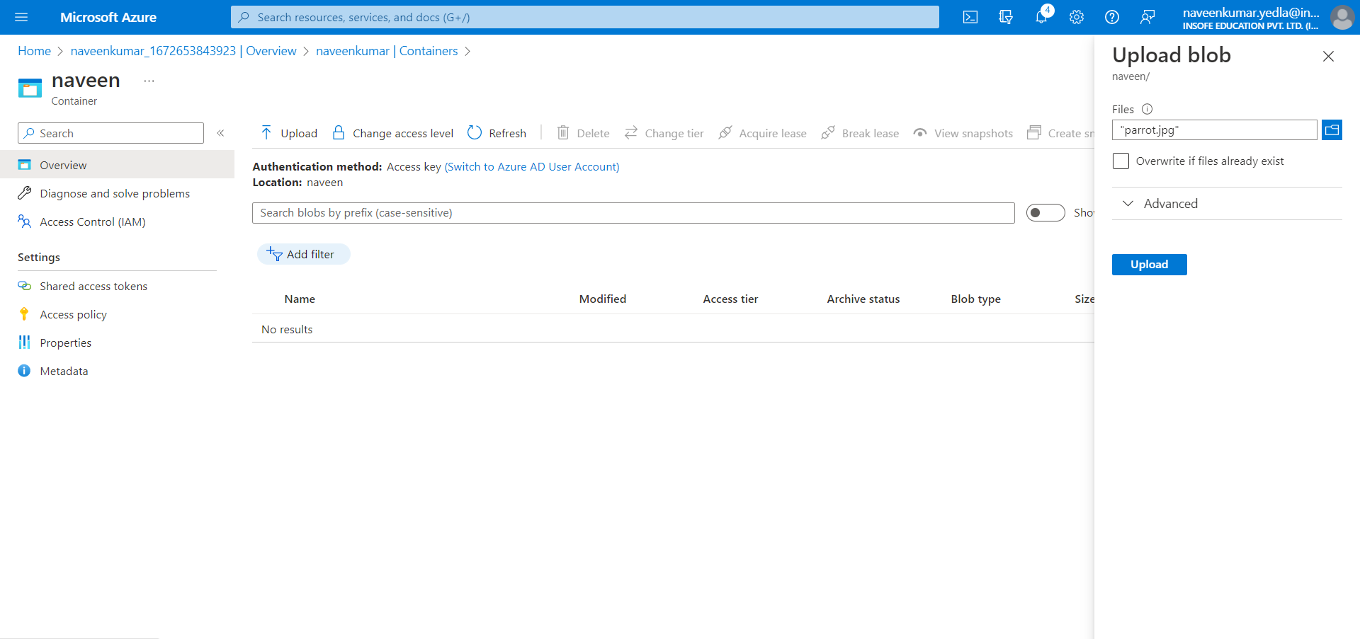

1. In blob storage it doesn’t have any file system.

**To create an Azure ADLS Gen2 storage account with the Azure portal, follow these steps:**

Data Lake Storage Gen2 makes Azure Storage the foundation for building enterprise data lakes on Azure. Designed from the start to service multiple petabytes of information while sustaining hundreds of gigabits of throughput, Data Lake Storage Gen2 allows you to easily manage massive amounts of data.

A fundamental part of Data Lake Storage Gen2 is the addition of a [hierarchical namespace](https://learn.microsoft.com/en-us/azure/storage/blobs/data-lake-storage-namespace) to Blob storage. The hierarchical namespace organizes objects/files into a hierarchy of directories for efficient data access. A common object store naming convention uses slashes in the name to mimic a hierarchical directory structure. This structure becomes real with Data Lake Storage Gen2. Operations such as renaming or deleting a directory, become single atomic metadata operations on the directory. There's no need to enumerate and process all objects that share the name prefix of the directory.

Data Lake Storage Gen2 builds on Blob storage and enhances performance, management, and security in the following ways:

* **Performance** is optimized because you don't need to copy or transform data as a prerequisite for analysis. Compared to the flat namespace on Blob storage, the hierarchical namespace greatly improves the performance of directory management operations, which improves overall job performance.
* **Management** is easier because you can organize and manipulate files through directories and subdirectories.
* **Security** is enforceable because you can define POSIX permissions on directories or individual files.

Also, Data Lake Storage Gen2 is very cost effective because it's built on top of the low-cost [Azure Blob Storage](https://learn.microsoft.com/en-us/azure/storage/blobs/storage-blobs-introduction). The extra features further lower the total cost of ownership for running big data analytics on Azure.

1. From the left portal menu, select Storage accounts to display a list of your storage accounts. If the portal menu isn't visible, click the menu button to toggle it on.
2. On the Storage accounts page, select Create.
3. Select the subscription for the new storage account.
4. Create a new resource group for this storage account, or select an existing one.

**Instance details**

1. Choose a unique name for your storage account. Storage account names must be between 3 and 24 characters in length and may contain numbers and lowercase letters only.
2. Select the appropriate region for your storage account.
3. Not all regions are supported for all types of storage accounts or redundancy configurations.
4. Select Standard performance for general-purpose v2 storage accounts (default). This type of account is recommended by Microsoft for most scenarios.
5. Select your desired redundancy configuration. Not all redundancy options are available for all types of storage accounts in all regions.

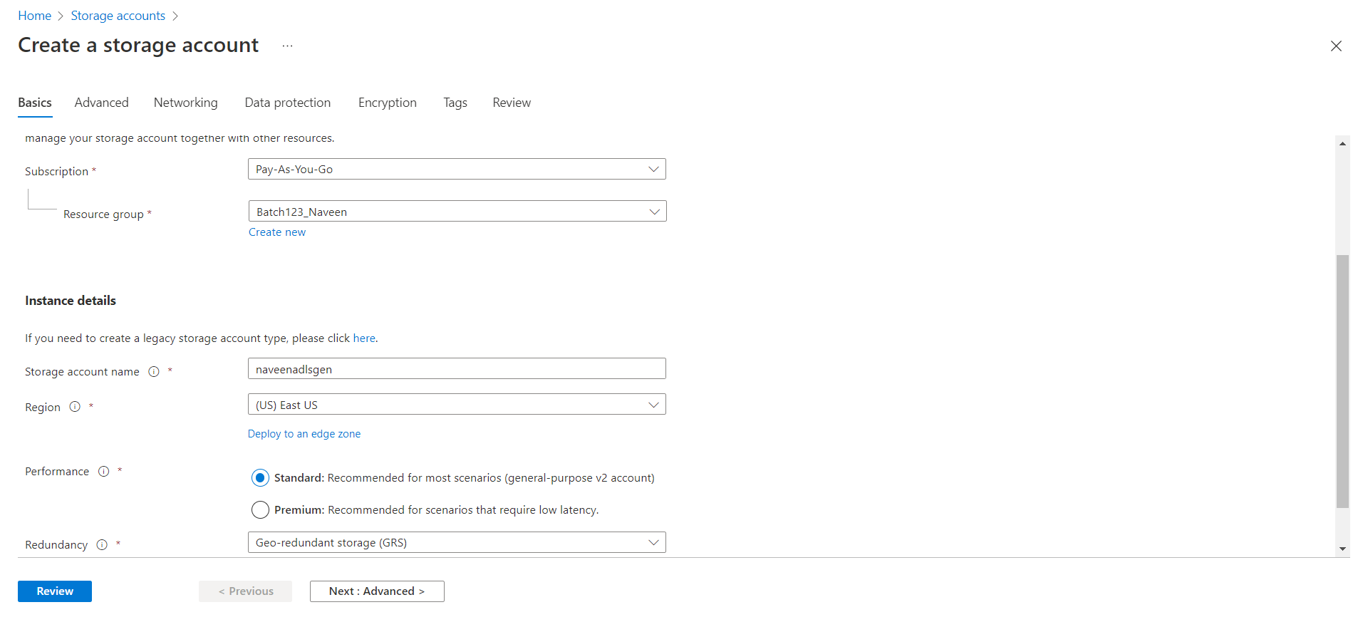

1. Click on Advance Tab
2. On Data Lake storage Gen2 Select Enable hierarchical name space. To create ADLS Gen2 Storage.

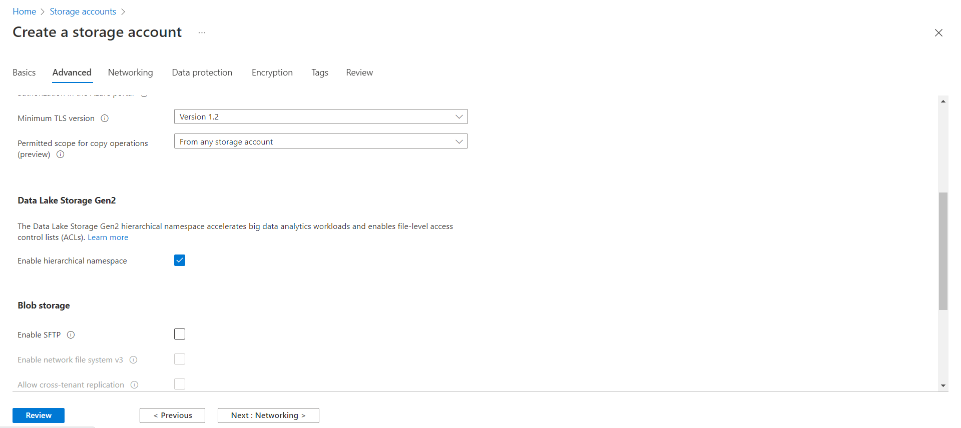

1. Click on create.

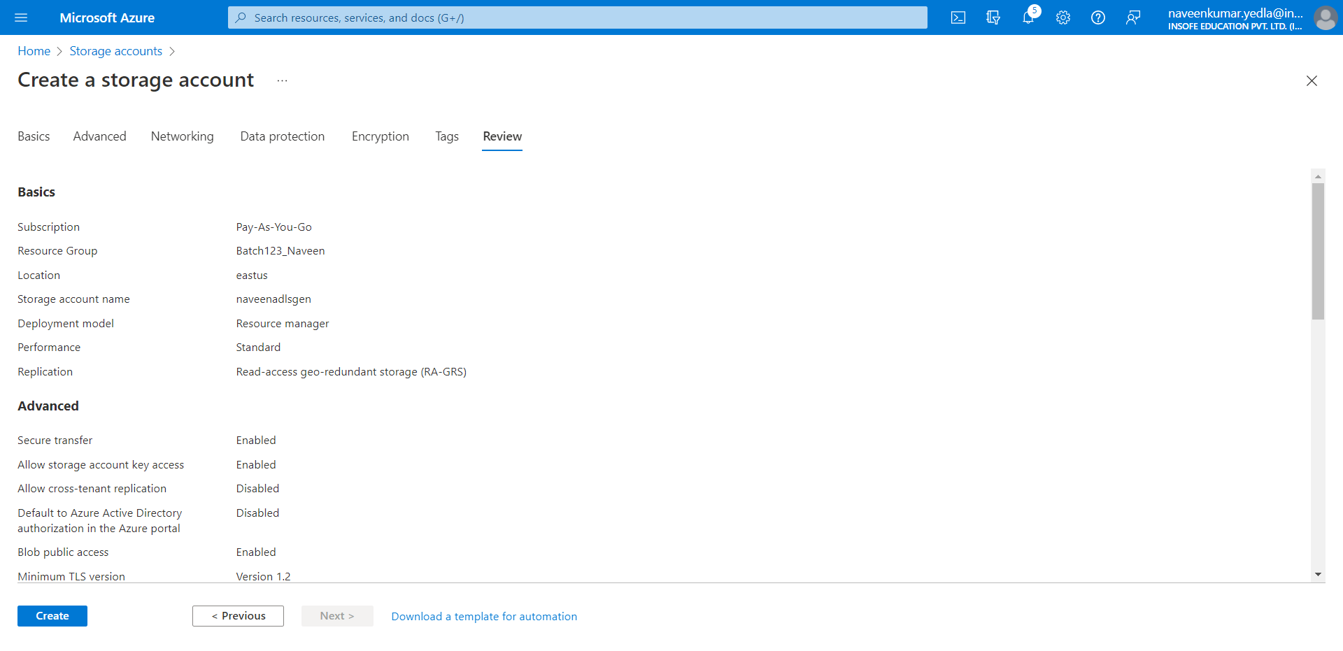

1. Select Go to resource.

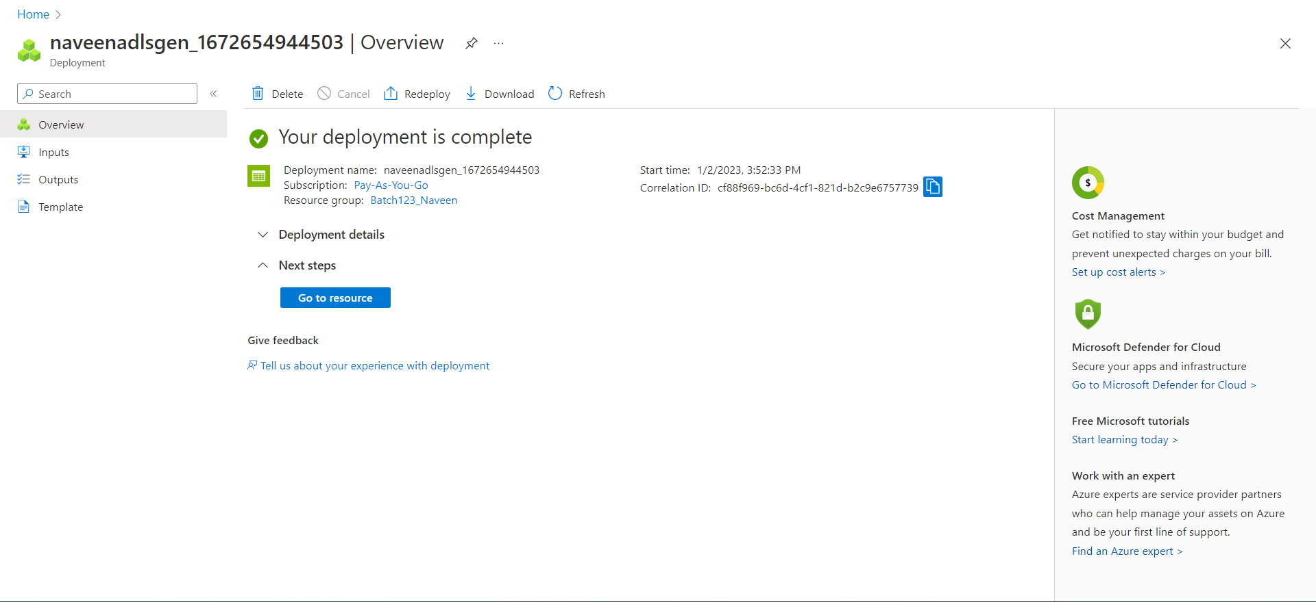

1. In Overview tab click on upload.
2. If you have already existing container, use it or create a new one.
3. Select files to upload.
4. Click on upload.

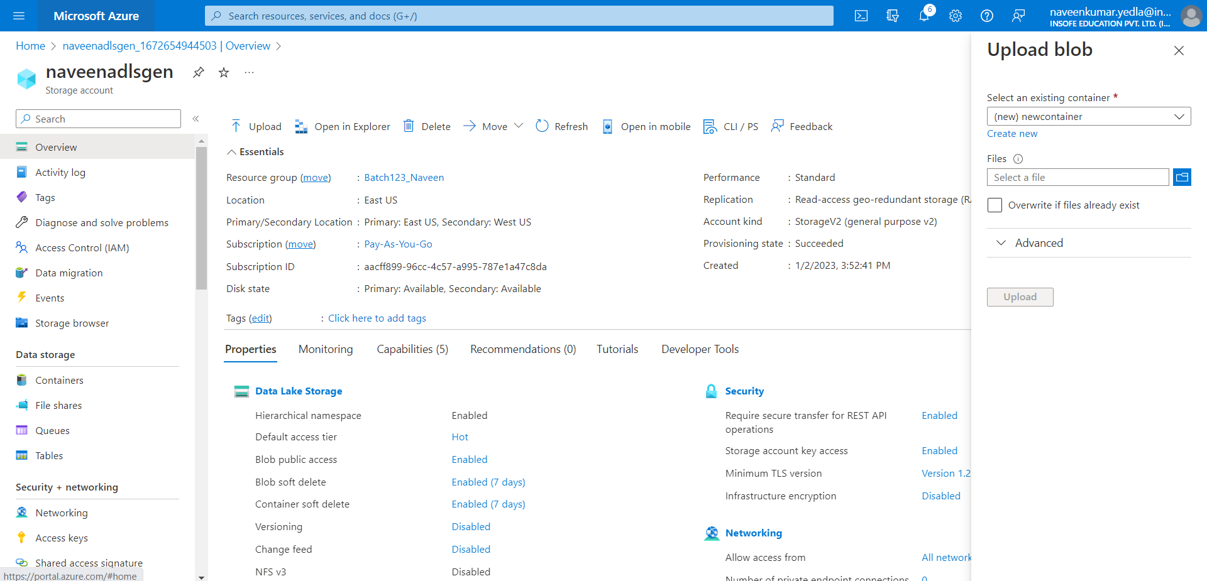

1. Select the container.

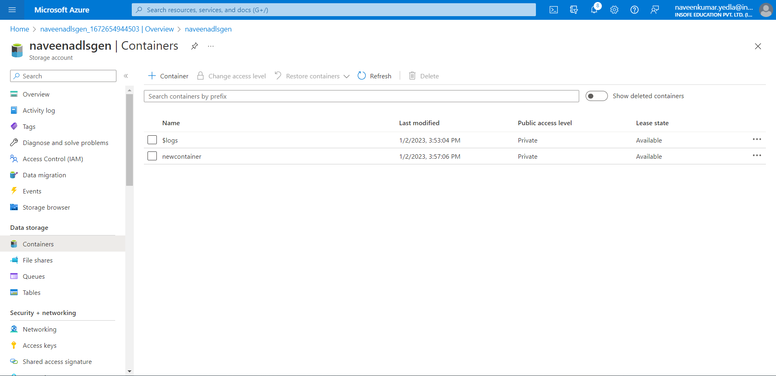

1. You can have directory in ADLS Gen2 shown Below

